# LAB # 7

**Objective: Combine cells in series and parallel and verify the net voltage. Equipment**

* + 4 x 1.5V AA batteries
  + Battery holders (for series and parallel configurations)
  + Digital Multimeter (DMM)
  + Connecting wires
  + Breadboard (optional)

**Theory**

**Series Configuration:** When cells are connected in series, the total voltage is the sum of the individual cell voltages.

**Vtotal = V1+V2+V3++** **+Vn**

**Parallel Configuration:** When cells are connected in parallel, the total voltage remains the same as the voltage of a single cell, but the total capacity (current) increases.

**Vtotal = Vcell**

**Procedure**

1. **Series Configuration**
   1. **Setup:**
      * Insert the batteries into the battery holders and connect them in series.
      * Connect the positive terminal of the first battery to the negative terminal of the second battery, and so on, until all batteries are connected in series.
      * Ensure the free positive and negative terminals are available for measurement.
   2. **Measurement:**
      * Set the DMM to measure DC voltage.
      * Connect the DMM probes to the free positive and negative terminals of the series-connected batteries.
      * Record the voltage reading.
2. **Parallel Configuration**
   1. **Setup:**
      * Insert the batteries into the battery holders and connect them in parallel.
      * Connect all positive terminals and all negative terminals together.
      * Ensure the free positive and negative terminals are available for measurement.
   2. **Measurement:**
      * Set the DMM to measure DC voltage.
      * Connect the DMM probes to the free positive and negative terminals of the parallel-connected batteries.
      * Record the voltage reading.

**Observations Cells in Series:**

|  |  |  |
| --- | --- | --- |
| **No. of Cells** | **Theoretical Voltage (V)** | **Measured Voltage (V)** |
| 2 | 3 V |  |
| 3 | 4.5 V |  |
| 4 | 6 V |  |

**Cells in Parallel:**

|  |  |  |
| --- | --- | --- |
| **No. of Cells** | **Theoretical Voltage (V)** | **Measured Voltage (V)** |
| 2 | 1.5 V |  |
| 3 | 1.5 V |  |
| 4 | 1.5 V |  |

**Analysis:**

* + - Compare the measured voltages with the theoretical voltages for each configuration.
    - Discuss any discrepancies between the measured and theoretical values and possible reasons (e.g., internal resistance of the batteries, contact resistance, accuracy of the DMM).

**Conclusion:**

Summarize your findings on how combining cells in series increases the voltage while combining them in parallel keeps the voltage the same as a single cell but increases the total capacity. Discuss practical applications of each configuration in real-world circuits.

**Safety Precautions:**

* + - Check battery orientation and ensure correct polarity to avoid short circuits.
    - Use insulated wires to prevent accidental short circuits and electric shocks.
    - Avoid short circuits by never directly connecting the positive and negative terminals of a battery without a load.

**Circuit Diagram:**

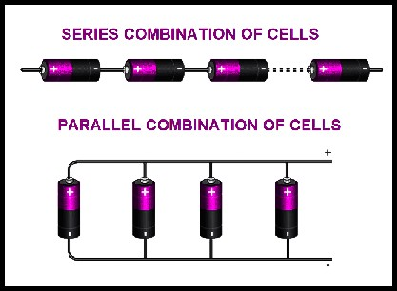

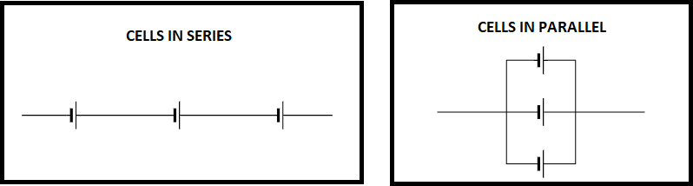

**POST LAB:**

1. How does the total voltage change when cells are connected in series?
2. How does the total voltage change when cells are connected in parallel?
3. If you connect five 1.5V cells in series, what should be the total voltage?
4. In a parallel configuration, if you use six 1.5V cells, what will be the total voltage?